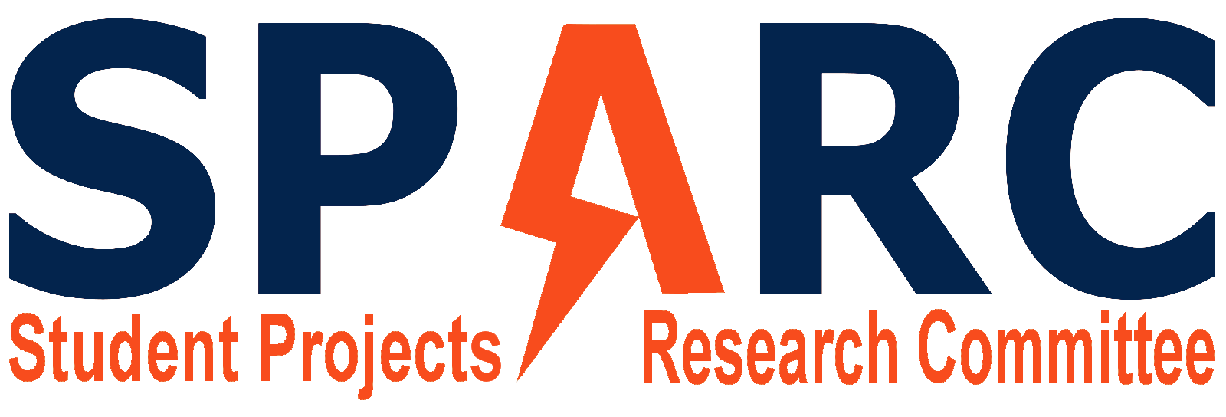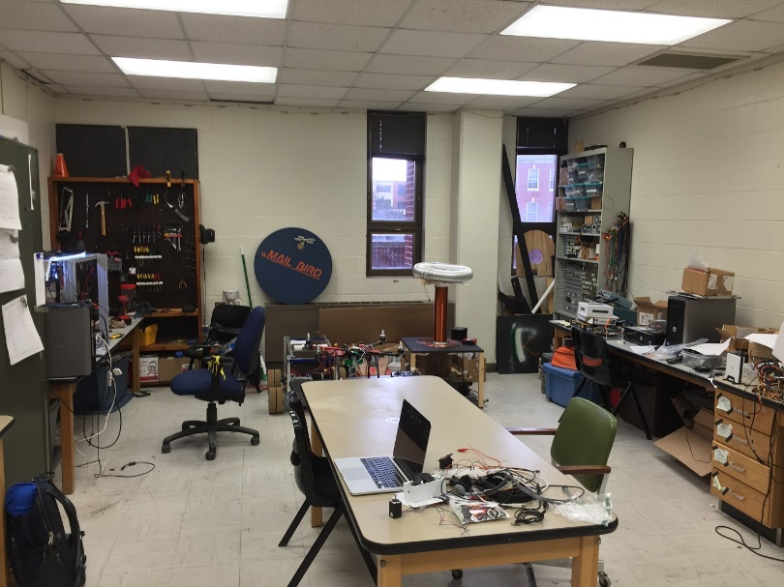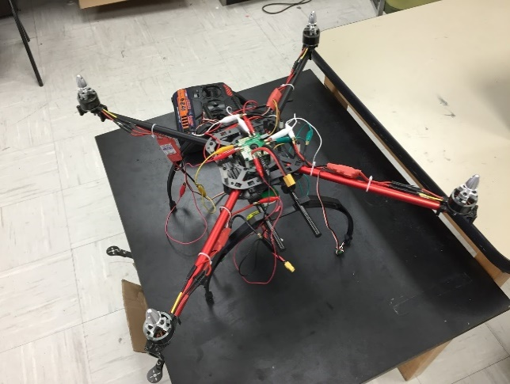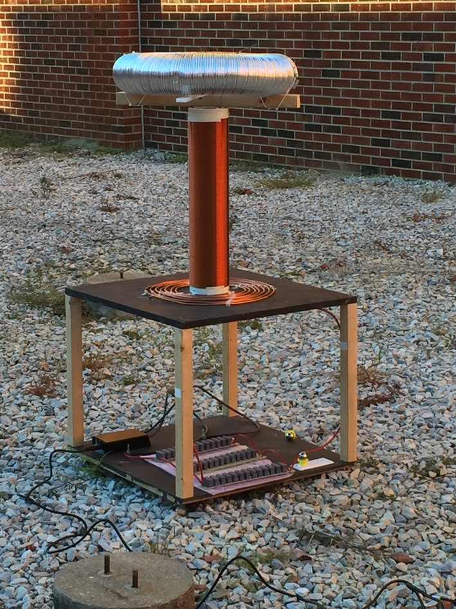

https://twitter.com/SPaRC_Auburn

https://github.com/SPARC-Auburn

<http://sparc-auburn.github.io/>

sparc.auburn@gmail.com

**Who can join?**

* Any student regardless of major or year can join.
* No experience is required and there is no required commitment

**Do you want to?**

* Get hands on experience and apply the concepts you learn in your classes.
* Learn programming, soldering, fabricating, 3D design, how to operate a 3D printer, and much more.
* Build robots, quadcopters, or any other project you can come up with.

**What is SPARC?**

* SPARC stands for Student Project and Research Committee.
* It basically functions as Auburn’s own “makerspace.”
* SPARC provides the resources and the funds for projects.

**Lab Location:**

Broun 368

**Spring 2016 Meeting Time:**

Tuesdays 6-7 in Broun 235